
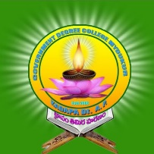

GOVT.DEGREE COLLEGE
MYDUKUR-516172
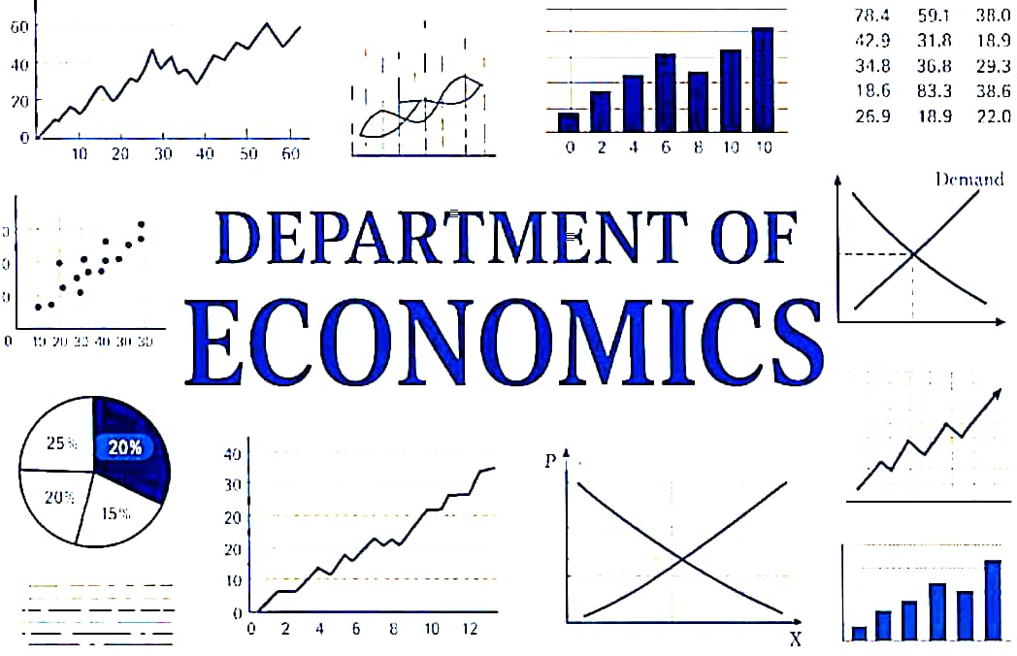

ACADAMIC YEAR 2025--2026
NAME OF THE LECTURER: Dr.M.Sudheer Reddy

GOVT. DEGREE COLLEGE

MYDUKUR-516172

DEPARTMENT OF ECONOMICS

MINUTES OF THE DEPARTMENTAL MEETING
25-6-2025
The department of Economics meeting conducted on 25-6-2025.
Agenda:
- Reviews about Examinations.
- Review about internships.
- Review about results.
- Review about Slow Learners.
- Review about Pule and Jogi varan Jayanthi celebrations.
- Discuss about competitive exams.

Resolution: As per the order of the principal Govt. Degree college, Mydukur ,
Mapping the internship.

Signature of the Staff Members Signature of the Principal

GOVT. DEGREE COLLEGE

MYDUKUR-516172

DEPARTMENT OF ECONOMICS

MINUTES OF THE DEPARTMENTAL MEETING

02-07-2025
The department of Economics meeting conducted on 02-07-2025.
Venue: Department of Economics
Time: 3 to 4 PM
Date: 02-07-2025
The principal of the college is the presided over the meeting.
All the members are requested to attend the meeting.
Agenda:
- Review about Admissions.
- Review about campaign.
- Review about results.
- Review the internship.
- Review the CSP projects.
- Review about Semester exams.

Resolution: As per the instructions of the principal GDC,Mydukur & Internship and CSP results viewers.

Signature of the Staff Members Signature of the Principal

GOVT. DEGREE COLLEGE

MYDUKUR-516172

DEPARTMENT OF ECONOMICS

MINUTES OF THE DEPARTMENTAL MEETING

10-8-2025
The department of Economics meeting conducted on 10-8-2025.
Venue: Department of Economics
Time: 12 to 1 PM
Date: 10-8-2025
The principal of the college is the presided over the meeting.
All the members are requested to attend the meeting.
Agenda:
- Review about admissions.
- Review about Results.
- Review about short term internship.
- Review about Independence Day celebrations.

Resolution: The department of Economics over reviews about the Admissions, short term internship as per the principal, GDC, Mydukur, celebrations of the 15th Aug 2025 Independence Day.

Signature of the Staff Members Signature of the Principal

GOVT. DEGREE COLLEGE

MYDUKUR-516172

DEPARTMENT OF ECONOMICS

MINUTES OF THE DEPARTMENTAL MEETING

11-09-2025
The department of Economics meeting conducted on 11-09-2025.
Venue: Department of Economics
Time: 2 to 3 PM
Date: 11-09-2025
The principal of the college is the presided over the meeting.
All the members are requested to attend the meeting.
Agenda:
- Discuss about 2nd phase admissions.
- Discuss about 3rd semester syllabus.
- Discuss about 1st semester syllabus.
- Discuss about short term internship.
- Celebration of World Population Day.

Resolution: The department of Economics had a resolution on the above points and took a decision on the implementation.

Signature of the Staff Members Signature of the Principal

GOVT. DEGREE COLLEGE

MYDUKUR-516172

DEPARTMENT OF ECONOMICS

MINUTES OF THE DEPARTMENTAL MEETING
20-10-2025
There will be a departmental meeting on 20-10-2025.
Venue: Department of Economics
Time: 3 to 4 PM
Agenda:
- Review of unit test results.
- Coverage of syllabus.
- Preparation of departmental action plan

Signature of the Staff Members Signature of the Principal

GOVT. DEGREE COLLEGE

MYDUKUR-516172

DEPARTMENT OF ECONOMICS

MINUTES OF THE DEPARTMENTAL MEETING
20-11-2025
The department of Economics meeting conducted on 20-11-2025.
Venue: Department of Economics
Time: 10 to 11AM
Date: 20-11-2025
The principal of the college is the presided over the meeting.
Agenda:
- Reviews about Aids Day Awareness programme.
- Reviews about World Human Rights Day celebrations.
- Reviews about Assignments.
- Reviews about Quiz/Group discussions.
- Review about Long –Term Internship for 3ndyear.

Signature of the Staff Members Signature of the Principal

GOVT. DEGREE COLLEGE

MYDUKUR-516172

DEPARTMENT OF ECONOMICS

MINUTES OF THE DEPARTMENTAL MEETING
20-12-2025
There will be departmental meeting on 20-12-2025.
Venue: Department of Economics
Time: 2 to 3 PM
All the members are requested to attend the meeting.

Agenda:
- Review of Syllabus
- Conduct of Mid Exams
- Remedial coaching

Signature of the Staff Members Signature of the Principal

